A Comprehensive Report on DistilBERT, and ALBERT

1. Introduction
The introduction of Transformer-based models revolutionized Natural Language Processing (NLP). Earlier approaches such as RNNs and CNNs struggled with long-range dependencies and efficient parallelization. BERT (Bidirectional Encoder Representations from Transformers) marked a major advancement by enabling deep bidirectional language understanding and achieving state-of-the-art results on many NLP tasks.
Despite its strong performance, BERT suffers from high computational and memory costs. These challenges led to the development of lighter models such as DistilBERT and ALBERT, which aim to retain BERT’s performance while improving efficiency.

2. DistilBERT: Model Compression via Knowledge Distillation

2.1 Motivation
DistilBERT aims to retain most of BERT’s performance while significantly reducing:
- Model size
- Inference latency
- Computational cost
Instead of redesigning the architecture from scratch, DistilBERT uses knowledge distillation.

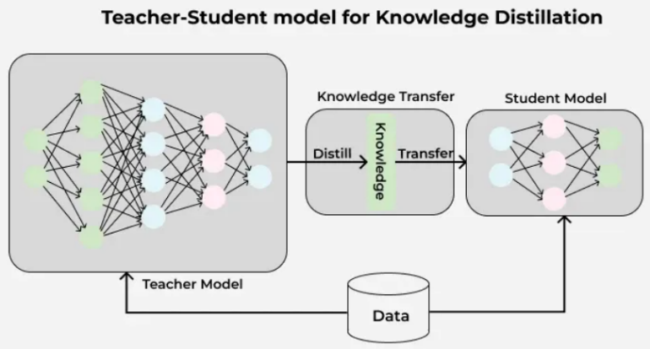
2.2 Knowledge Distillation Theory
Knowledge distillation involves:
- A large, pre-trained model (Teacher, BERT)
- A smaller model (Student, DistilBERT)

The student learns not only from true labels, but also from the soft probability distributions produced by the teacher. These soft targets contain richer information about class relationships.

2.3 DistilBERT Training Objective
DistilBERT uses a combined loss function:
- Distillation Loss (KL Divergence)
  - Aligns student output distribution with teacher output
- Masked Language Modeling Loss
  - Preserves linguistic knowledge
- Cosine Embedding Loss
  - Encourages similarity between hidden representations of student and teacher
This multi-loss framework ensures that the student learns both output behavior and internal representations.

2.4 Architectural Simplifications
Compared to BERT:
- Number of layers reduced from 12 to 6
- Token-type embeddings removed
- Pooler layer removed
Despite these reductions, attention heads and hidden dimensions are preserved.

2.5 Performance Characteristics
- ~40% smaller than BERT
- ~60% faster inference
- Retains approximately 95–97% of BERT’s performance
DistilBERT is particularly well-suited for production systems, mobile applications, and real-time NLP tasks.

3. ALBERT: A Lite BERT Through Parameter Efficiency

3.1 Motivation
ALBERT focuses on reducing the number of parameters, not merely layers. The key insight is that many parameters in BERT are redundant.
ALBERT introduces architectural innovations to reduce redundancy while preserving representational power.

3.2 Factorized Embedding Parameterization
In BERT:
- Embedding size = hidden size
This creates a large embedding matrix.
In ALBERT:
- Embedding size is decoupled from hidden size
- A smaller embedding matrix is projected into a larger hidden space
This significantly reduces parameter count without harming performance.

3.3 Cross-Layer Parameter Sharing
Instead of each Transformer layer having unique parameters:
- ALBERT shares parameters across all layers
- Attention weights and feed-forward weights are reused
This results in:
- Massive parameter reduction
- Regularization effect
- Improved generalization

3.4 Sentence Order Prediction (SOP)
ALBERT replaces NSP with Sentence Order Prediction:
- Two consecutive segments are either in correct or swapped order
- Focuses on discourse coherence rather than topic similarity
SOP was empirically shown to be more effective than NSP.

3.5 ALBERT Variants and Efficiency
- ALBERT-base: ~12M parameters
- ALBERT-large and xlarge scale depth, not parameters
ALBERT achieves performance comparable to or better than BERT with a fraction of the parameters.

4. Comparative Analysis
Feature | BERT | DistilBERT | ALBERT
Parameters | ~110M | ~66M | ~12M
Layers | 12 | 6 | 12 (shared)
Compression Strategy | None | Knowledge Distillation | Parameter Sharing
Inference Speed | Slow | Fast | Fast
Memory Usage | High | Medium | Very Low
Production Suitability | Limited | High | High

5. Practical Use Cases
All three models are used in:
- Text classification
- Sentiment analysis
- Named Entity Recognition
- Question answering
- Information retrieval
- Conversational AI
Model selection guidelines:
- Use BERT when maximum accuracy is required and resources are available
- Use DistilBERT for fast, real-time systems
- Use ALBERT for memory-constrained environments or large-scale deployment

6. Conclusion
BERT introduced a paradigm shift in NLP by enabling deep bidirectional contextual understanding. However, its computational cost motivated research into efficiency-oriented architectures.
DistilBERT demonstrates that much of BERT’s knowledge can be compressed into a smaller model through knowledge distillation, while ALBERT shows that architectural redesign and parameter sharing can dramatically reduce model size without sacrificing performance.
Together, these models represent the evolution of NLP from pure performance optimization toward scalable, efficient, and production-ready language understanding systems.

7. Refrences
DistilBERT :-
https://www.geeksforgeeks.org/nlp/distilbert-in-natural-language-processing/
https://medium.com/huggingface/distilbert-8cf3380435b5

ALBERT :-
https://medium.com/data-science/albert-22983090d062
https://www.geeksforgeeks.org/machine-learning/albert-a-light-bert-for-supervised-learning/

